**Explicit cursor Q1**

Create a hostel mess database with fields(stud_no, name, messfee, veg/nonveg). Write a PL/SQL program to increase the mess fee of vegetarians by 10% and non vegetarians by 20%. Also create tables vegetarian and non_vegetarian which includes fields: stud_no, name, raise_in_fee and date on which raise was given. Insert values into these tables through PL/SQL program.



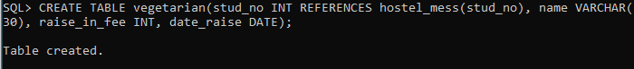

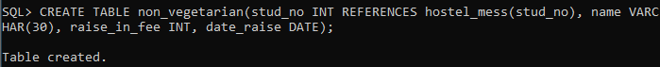

**Program:**

declare

cursor c is SELECT * FROM hostel_mess;

a hostel_mess%rowtype;

raise_fee number;

begin

open c;

loop

FETCH c INTO a;

exit when c%notfound;

if a.veg_nonveg='veg' then

raise_fee:=a.messfee*0.1;

UPDATE hostel_mess SET messfee=messfee+raise_fee WHERE stud_no=a.stud_no;

INSERT INTO vegetarian VALUES(a.stud_no, a.name, raise_fee, sysdate);

elsif a.veg_nonveg='nonveg' then

raise_fee:=a.messfee*0.2;

UPDATE hostel_mess SET messfee=messfee+raise_fee WHERE stud_no=a.stud_no;

INSERT INTO non_vegetarian VALUES(a.stud_no, a.name, raise_fee, sysdate);

end if;

end loop;

close c;

end;

**Output:**

